**Experiment 35**

**AIM :**

To design NFA transition diagram of strings of bbc,c,bcaaa in automata.

**Design and output:**

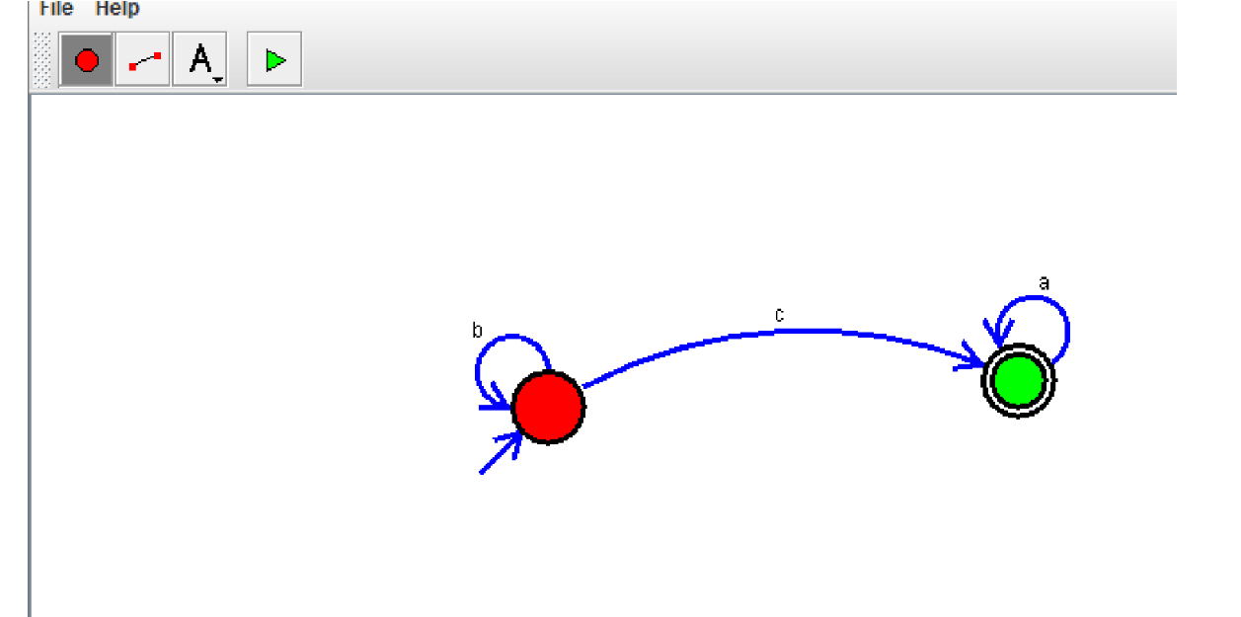

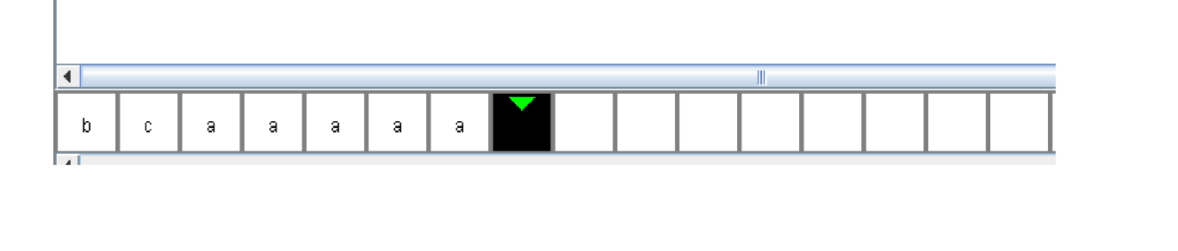

**Result:** Thus designing NFA transition diagram of strings of bbc,c,bcaaa is done and verified by giving sample inputs.